Discussion Exercises for Access Protocols
IMPORTANT: Before beginning these exercises, you must have participants informed consent to do so. Read Informed consent on the FirstVoices Knowledge Base about what goes into obtaining and documenting informed consent.

Guidelines
You can use these exercises to begin discussions and learn more about traditional knowledge sharing practices with Elders and Knowledge Holders. These activities are meant to be collaborative and multi-modal: using different senses and response techniques to begin discussions. Through the conversations you have, you can begin to form a more culturally centred approach to access protocols surrounding archives.
Feel free to modify these exercises to best fit your needs and to remain appropriate to cultural protocols and access protocols that may already exist in your archive.
When handling and working with delicate records, keep food and drinks away from these materials. Use cotton gloves when handling certain records like film and photographs (Photographic Negatives).
*In case these exercises are done during the COVID-19 pandemic, always adhere to provincial and community safety protocols and guidelines.
Operate in a well-ventilated space (if possible) and use personal protective equipment (PPE) when in proximity with other individuals.
If any party is feeling ill prior to gathering, postpone the exercises, and the affected person(s) should be encouraged to seek appropriate medical treatment.

Suggestions
- If an Elder or Knowledge Holder has trouble seeing, bring magnifying glasses or a projector to aid them in reading small print and details.
- If an Elder of Knowledge Holder has difficulty hearing, bring a portable speaker or multiple headphones with a sharing input to aid them in listening to audio.
- Set out and prepare the space you will be working in before your Elder(s) arrive.
- Take breaks in between exercises or reviewing resources.
- If you have the informed consent to do so, consider recording the exercises for continuity and the archive’s own records.

Exercise 1: Mapping
Description: Archives often contain maps and charts of territories and waterways. Some information on these documents may be in an Indigenous language and other times not. In this exercise, you will talk about placenames and memories ar0und different locations.

Throughout the exercise, Elders or Knowledge Holders might have questions about who helped create these maps, what certain icons or characters mean on, and offer suggestions about how to improve on them in future versions. Take this feedback and provide what information you can about these resources’ origins during this activity.

Step 1. Lay out your map(s) and arrange them in a way so they continue into each other (see example).

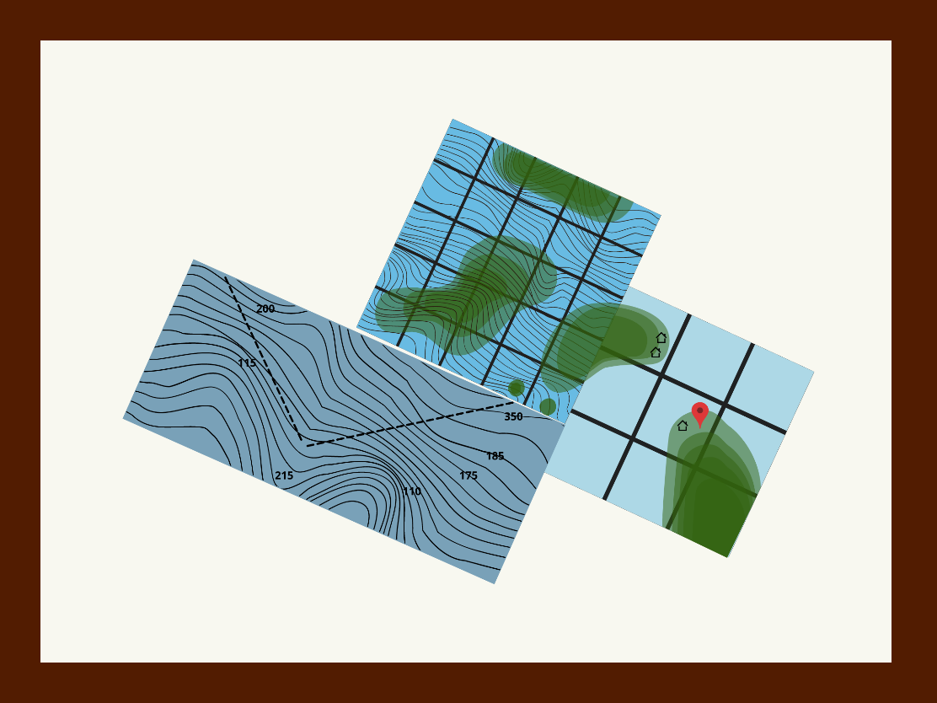

Step 2. Begin by asking if anyone recognizes some frequently visited places. Note where widely recognized locations and areas are (e.g., where town is, the band store, etc.)

Step 3. Discuss: how long the town/other locations of note have been there, if there are other places where people live/used to live, and where we would find these places on the map(s).

Step 4. Ask if anyone has any stories about these places or memories they would like to share. If more than one person would like to share, take turns sharing and give everyone ample time.
If no one volunteers, offer up a light-hearted story yourself about a common location.

Step 5. Discuss: what is the best way to share this type of memory or a place-based story, would it be a story that can be shared, and how would someone who wants to hear this story go about finding it.

Step 6. Repeat this process with other locations/points of interest on the map(s). Let the Elders and Knowledge Holder(s) guide the conversations.
Take note of what Elders and Knowledge Holders share and what they think is important for people to know about what they describe.

Step 7. Once you have discussed and feel satisfied with the exercise, ask some closing questions for group reflection:
- What types of stories and language do you want to hear about the land and waters?
- What types of stories and language about the land and waters are you comfortable sharing?
- What stories and language about land do you think everyone should know about?
Run time: approximately 3 hours.

Exercise 2: Listening
Description: Archives that contain language materials will often contain a variety of audio recordings. Some will be more fragile than others to play, and they will all possess important information about language, culture, history, and more. In this exercise, you will listen and reflect on archival recordings.
Throughout the exercise, Elders or Knowledge Holders might have questions about who helped create these recordings originally, who digitized them, and offer suggestions about how to improve or re-record them in future versions. Take this feedback and provide what information you can about these resources’ origins during this activity.

Step 1. Find three to four different audio recordings that you can play for a group of Elders or Knowledge Holders. Consider playing different types of recordings with varying topics (e.g., one 15-minute discussion about berry-picking and an everyday conversation in the language).

Step 2. Explain the sequence that you will play the recordings to the group and ask if there are any questions:
- First Playback: The whole recording with no pauses
- Second Playback: The recording with pauses (listeners can signal to pause to add comments)
- Third Playback: The whole recording with no pauses

Step 3. Play the First Playback all the way through once without pauses to let everyone have a first listen.
Do a sound check that everyone could hear the recording clearly.

Step 4. Give people some time to reflect, then perform the Second Playback with pauses.
Have listeners signal (e.g., raise a hand / hold up a ping pong paddle) if they want to comment on what they hear; pause the recording and let anyone who wants to speak add to the conversation during these breaks.

Step 5. Perform the Third Playback.
Once the recording is finished, pause, and ask the group what their overall thoughts are about what was played. Discuss:
- Have you heard this recording before?
- What stood out to you about this recording?
- Who do you think would benefit from this recording?
Note down any insights from the group.

Step 6. Repeat this process with the remaining recordings you have queued. Provide time to take breaks between recordings.

Step 7. Once you have discussed and feel satisfied with the exercise, ask some closing questions for group reflection:
- How would be the best way to share the recordings we listened to today (and would you like a copy)?
- What types of stories and language are you comfortable sharing through recordings?
- Are these recordings today that we heard ones that you think everyone should know about?
Run time: 3-4 hours.

Exercise 3: Witnessing
Description: Some archives or culture centres will have many belongings or artefacts in their collections too. These tangible pieces of heritage are often good places to start and centre conversations around language.

Step 1. Gather and prepare a small assortment (4-5 tangible heritage pieces) for display and discussion.
Select objects and other belongings that you know do not have specific protocols for unveiling or presenting. Ensure that you have gloves, hand sanitizer, and other materials necessary for handling any delicate pieces.

Step 2. Station each of the pieces separately with enough room for Elders/Knowledge Holders to take turns and spend time with each set-up (see image).

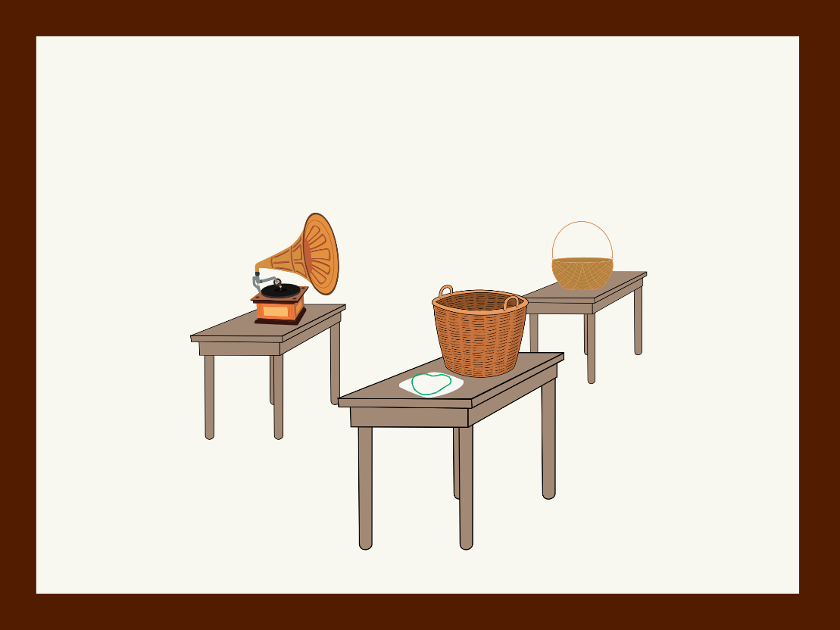

If the exercise participants consent to be recorded during this exercise, you can station microphones by each of the items to record their observations

Step 3. With the group, explain what archival metadata or knowledge you have of each piece on display. Allow Elders and Knowledge Holders to take time to observe, hold, and experience these belongings.
Throughout the exercise, Elders or Knowledge Holders might have questions about who donated these items, where and how they are currently stored, and offer suggestions about how to improve care or adhere to cultural protocols with specific belongings.
Take this feedback and provide what information you can about these resources’ origins and maintenance during this activity.

Step 4. Come back together as a group and provide room for people to share what they thought or remembered while interacting with the displays.
Some guiding questions for the group are:
- Who else should be able to witness and interact with these cultural objects?
- How and when is it appropriate to share them?
- What are ways to connect these belongings with language initiatives today?
Note down any insights, especially if they pertain to language or protocols around these items under discussion.
Run time: 2-3 hours.

It is recommended that you use sturdier maps and charts compared to fragile ones for this exercise. If you are concerned about wear-and-tear, use digitized copies, or duplicates available to you.
It is recommended that you select recordings that are no more than 20-minutes long in their entirety. Given the length of the exercise, long recordings can draw it out and leave Elders fatigued. If you do not get through all the recordings, you can also break the exercise into two sessions.

